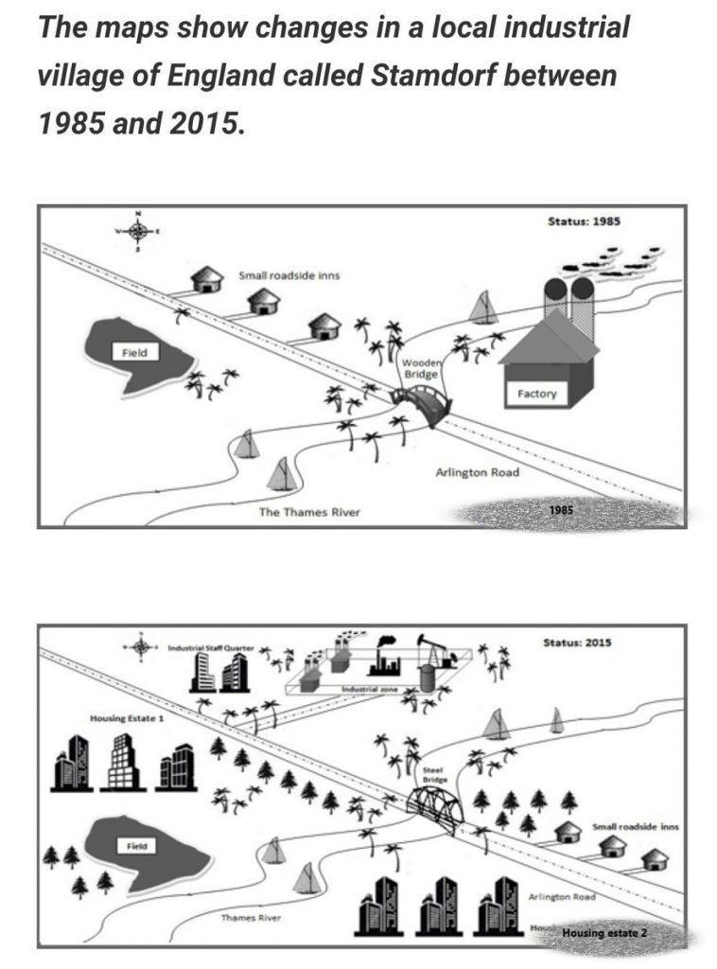

**DÀN Ý LẦN 1**

**Intro:**

* There were vast changes to the village as a result of industrialization.
* More industrial facilities and housing estates, as well as the relocation of a field and some inns.

**Body 1: 1985**

* a field in the west.
* three small inns along Arlington road.
* a factory to the southeast of the wooden bridge.

**Body 2: 2015**

* the western field was relocated southward to give way to the construction of a housing estate numbered 1.
* the roadside inns were transplanted to the southeast of the map to make way for the erection of an industrial staff quarter.
* a side road which gave access to a newly-established industrial zone.
* the demolition of the factory near the bridge which was reconstructed into a steel one.
* the second housing estate opposite the roadside inns.

**BÀI LÀM LẦN 1**

Cách viết dạng map https://www.ieltstutor.me/blog/map

Provided are the maps depicting the transformation of Stamdorf village in the UK in 2015 in comparison to 1985. Overall, this region experienced significant changes as a result of industrialization, with the introduction of more industrial facilities and housing estates, as well as the relocation of a field and some inns. **⇒ Phần Overview này mình miêu tả ổn nhé.**

In 1985, there was a field in the west of the map, and to the west of it were three small inns along Arlington road. To the southeast of the wooden bridge was located a factory.

**⇒ Thứ tự thông tin mình miêu tả ở Body 1. thì nên được đồng nhất ở Body 2. nhé**

**Và ở đây Map 1. Mình nên đầy đủ thông tin cần thiết của Map ra nhé.**

***VD:***

***Body 1. A main road - Arlington Road ran across the village and the river through a wooden bridge***

***To the left of Arlington Road, + Field***

***On the right-hand side of Arling Road, + Inns***

* ***Factory***

**⇒ Miêu tả từ ĐÁNG CHÚ Ý --> ÍT ĐÁNG CHÚ Ý --> GIỮ NGUYÊN** [**https://www.suabaiieltswriting.com/blog/cach-mo-ta-map-ielts-writing-tu-bao-quat-den-chi-tiet-tu-ngoai-vao-trong-tu-phai**](https://www.suabaiieltswriting.com/blog/cach-mo-ta-map-ielts-writing-tu-bao-quat-den-chi-tiet-tu-ngoai-vao-trong-tu-phai)

However, a wide variety of modifications were made to the village in 2015. First off, the western field was relocated southward to give way to the construction of a housing estate numbered 1. Similarly, the roadside inns were transplanted to the southeast of the map to make way for the erection of an industrial staff quarter. Besides, in close proximity to the quarter was built a side road which gave access to a newly-established industrial zone. One noteworthy alteration is the demolition of the factory near the bridge which was reconstructed into a steel one. Opposite the roadside inns emerged the second housing estate.

**Vậy sang Body 2. Thì mình sẽ cần sự đồng nhất cho thông tin miêu tả để người đọc theo dõi được nhé.**

***VD:***

***Body 2. A wooden bridge → a steel bridge + Main Road remained***

***To the left of Arlington Road, + Field was relocated below Housing Estate 1***

* ***Further down the south, Housing Estate 2 was constructed***

***On the right-hand side of Arling Road, + Inns were shifted to the area of the former factory***

* ***Factory was moved to the north, developed into a massive industrial area***
* ***An industrial staff quarter was built beside.***

*(191 words)*